Respect
To be considerate of others and to be tolerant of differences

"Respect cannot be learned, purchased or acquired it can only be earned." ~Anonymous

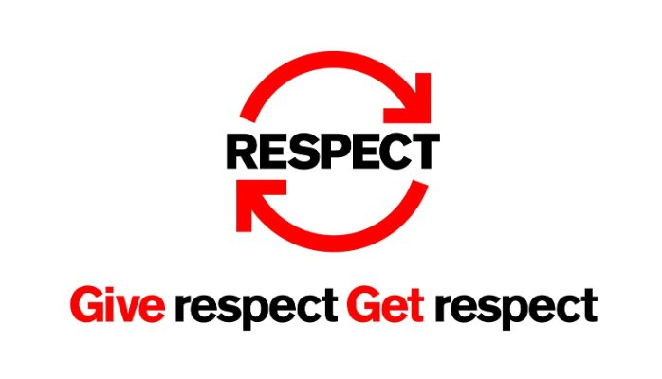

Character Education Program for October- RESPECT
Definition of RESPECT:
Behavior intended to please others, to show regard or consideration for others and their beliefs and feelings.
What You Will See As We All Show RESPECT for One Another:
- Students will treat each other with respect.
- They will follow the Golden Rule.
- They will be tolerant of differences.
- Use good manners with everyone.
- Be considerate of the feelings of others.
- Deal peacefully with anger, insults and disagreements.
- Look for positive ways to solve problems.

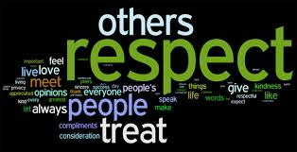
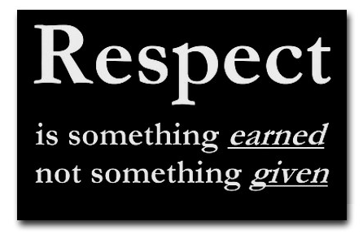
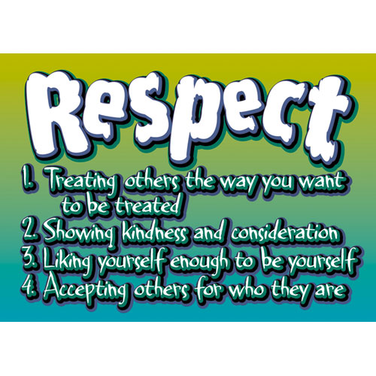
Quotes About RESPECT:
"Respect yourself and others will respect you." ~ Confucius
"Respect cannot be learned, purchase or acquired- it can only be earned." ~Anonymous
“Respect is a two-way street, if you want to get it, you’ve got to give it.” ~R.G. Risch
"I must respect the opinions of others even if I disagree with them." ~Herbert Henry Lehman
"Try not to become a man of success, but rather try to become a man of value." ~Albert Einstein
“I firmly believe that respect is a lot more important, and a lot greater, than popularity.” ~ Julius Erving

The following stories are read over the daily announcements during homeroom/advisory usually once a week or they can be incorporated into individual classes.
October Character Story about RESPECT:
Good Morning, (name of school). This is _________ with a few words of wisdom about our character word for the month of October- RESPECT.
A well-known speaker started off his seminar by holding up a $20 bill. In the room of 200 people, he asked, "Who would like this $20 bill?"
Hands started going up. He said, "I am going to give this $20 to one of you- but first, let me do this."
He proceeded to crumple up the $20 bill. He then asked," Who still wants it?" Still the hands stayed up in the air.
"Well," he replied, "what if I do this?" He dropped the $20 on the ground and started to grind it into the floor with his shoe. He picked it up, now crumpled and dirty. "Now, who still wants it?"
Again the hands stayed up in the air.
"My friends, you have learned a very valuable lesson. No matter what is did to the money, you still wanted it because it did not decrease in value. It was still worth $20.
Many times in our lives, we are dropped, crumpled and ground into the dirt by the decisions we make and the circumstances that come our way. We feel as though we are worthless; but no matter what happened or what will happen, YOU will never lose your value.
Dirty or clean, crumpled or finely creased, you are still priceless to those who love you. The worth of our lives comes, not in what we do or who we know, but by...WHO WE ARE."
Respect yourself – you are very special- don't ever forget that!
With something to think about, this is _____________. Make it a great day.

October Character Story about RESPECT
Good Morning (name of school). I am ________ and I would like to share a story that reinforces our character word for the month of October- RESPECT.
In the days when an ice cream sundae cost much less, a 10 year old boy entered a soda shop and sat at a table. A waitress put a glass of water in front of him.
"How much is an ice cream sundae?" He asked.
"Fifty cents," replied the waitress.
The boy reached into his pocket and pulled out an assortment of change, counting it carefully. "Well, how much would a plain dish of ice cream be?" he asked.
By now, more people were waiting for a table and the waitress was growing impatient.
"Thirty-five cents," the waitress said quite irritated.
The boy counted his coins again.
"May I have the plain dish of ice cream then, please?" He asked.
The waitress brought the ice cream, put the bill on the table and walked away.
The boy finished his ice cream, paid the cashier and left.
When the waitress returned later, tears welled up in her eyes as she cleared the table. Placed neatly beside the boy's empty dish were two nickels and five pennies.
She realized that the boy had the money to buy an ice cream sundae, but sacrificed it so that he could leave her a tip out of respect.
With something to think about, this is ____________. Make it a great day.

October Character Story about RESPECT
Good Morning, (name of school). I am ______________ and I would like to share a story that reinforces our character word for the month of October- RESPECT.
Mark is a student in his first year of college. His professor, in one of his classes, gave the students a pop quiz. Mark is a conscientious student and breezed through the questions, until he read the last one: "What is the first name of the woman who cleans this building in our school?"
Surely this was some kind of joke. He had seen the cleaning woman several times. She was tall, dark-haired and in her 50's, but how would he know her name? He handed in his paper, leaving the last question blank.
Just before class ended, one student asked if the last question would count toward their quiz grade.
"Absolutely," replied the professor. "In your careers, you will meet many people. All of them are significant. They each deserve your attention and care, even if all you do is smile and say hello." Mark never forgot that lesson. He also learned that the woman who cleans their building is named Dorothy.
This week in advisory brainstorm and discuss ways to show respect for others.
With something to think about, this is ________________. Make it a great day.

October Character Story about RESPECT
Good Morning, (name of school). I am ______________ and I would like to share a quote that reinforces our character word for the month of October- RESPECT.
The following is a famous quote, "Respect cannot be learned, purchased or acquired – it can only be earned."
This quote is important because no matter how influential you are or how much money you make or what kind of car you drive—you still have to earn respect by your actions. Respect is not something tangible that you can touch or see but instead a feeling that people have about you because of the thoughtful and good things that you do. Respect is not something that you earn in a month or two but it develops over time.
Here are some examples of how you can show people respect:
- Look people in the eye when you speak
- Ask permission before doing something
- Notice what is important to your family and friends
- Say please and thank-you
- Keep your word
- Listen to other viewpoints when in a conversation with friends and don't interrupt
- Make sure that everyone around you feels included
Take the time to show respect to others and you will earn the respect of your peers and the adults in your life.
This week in advisory, discuss ways to show respect at home and in school.
With something to think about, this is ______________. Make it a great day.

October Character Story about RESPECT
Good Morning, (name of school). I am ____________ and I would like to share a quote that reinforces our character word for the month of October- RESPECT.
Confucius said, "Respect yourself and others will respect you."
This quote demonstrates the true meaning of respect. Respect is being positive towards yourself and others when the easier option is being negative. Respect is giving people a chance, believing in opportunity and understanding that because some one is different, doesn't mean you both don't deserve respect. Your peers are always watching to see how you will handle certain situations and from your actions you earn respect. When people respect you they know that they can count on you to always have their back.
Last wee in advisory, you discussed ways to show respect at home and in school.
Here are some examples of how you can show respect at home and school.
- Help around the house
- Do things the first time that you are asked
- Say please and thank-you
- Be someone that others can depend on
- Have a positive attitude
- Take pride in your accomplishments and those of your family and friends
With something to think about, this is ______________. Make it a great day.

Character Poster Hung on Every Door in our School:
Respect Goals
"Respect is something earned, not given."
- Hold the door for others when entering and exiting our school.
- Say please and thank-you to peers and staff.
- Greet staff and peers at school each day.
- Ask adults (parents, teachers, coaches, neighbors) is they need any help.
- Help out at home without being asked.
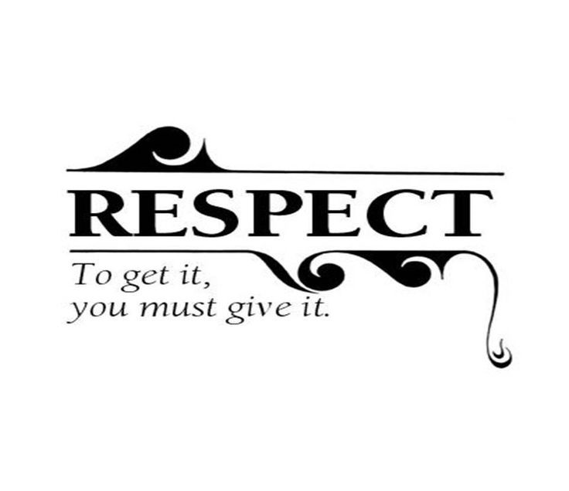

Peer Leader Lesson Plan with RESPECT theme:
This lesson is taught by my 8th grade peer leaders as they mentor 6th graders with a character lesson taught each month for about 20 minutes. The 8th graders teach in groups of 4 and go to a 6th grade study hall.
Peer Leader Lesson Plan Outline:
- Introduce yourself and tell the class that today's lesson is about RESPECT.
- Write the word RESPECT on the board- have a couple students come up and write a definition. (Ex. A feeling of deep admiration for someone because of their abilities, qualities or achievement and treating others with kindness.)
- Hand out The Cookie Thief story to each person in the class (a copy of the story follows this lesson plan). Have them follow along as the peer leaders take turns reading the story out loud.
- Have the students come up and write comments on the board- a couple of 6th graders at a time- about the story or if you see that you are running out of time have them make comments verbally.
- Turn the worksheet over and take a look at the questions.
- You can break into smaller groups or do the questions all together. Walk around the classroom and choose a variety of students to answer the questions.
- Closure with about 2 minutes left of class- We have all made mistakes and many times we keep our problems bottled up inside of us and do not talk them out. We need to talk to each other, listen to each other and respect each other.
- Watch your time- you do not have to finish the entire worksheet; but be sure that you give closure to the lesson. If the bell rings while you are teaching- you dismiss when you are done with the lesson.

The Cookie Thief
A woman was waiting at an airport one night, for several hours before her flight. She hunted for a book in the airport shops, bought a bag of cookies and found a place to sit and spread out her things.
She was engrossed in her book but happened to see, that a man sitting beside her, as bold as could be, grabbed a cookie or two from the bag in between them, which she tried to ignore to avoid a scene. She munched the cookies and watched the clock, as the gutsy cookie thief diminished her stock and blatantly continued to eat the cookies. She was getting more irritated as the minutes ticked by, thinking, "If I wasn't so nice, I would blacken his eye." With each cookie that she took, he took one, too. When only one cookie was left, she wondered what he would do. With a smile on his face, and a nervous laugh, he took the last cookie and broke it in half. He offered her half as he ate the other half. She snatched it from him and thought, "This guy has some nerve and he is so rude. Why he didn't even show any gratitude!"
She had never known when she had been so shocked and she sighed with relief when her flight was called. She gathered her belongings and headed to the gate, refusing to look back at the cookie thief.
She boarded the plane, and sank in her seat, then looked for her book which was almost done. As she reached in her baggage, she gasped with surprise, because there was her bag of cookies, right there in her bag. If my cookies are here, she moaned to herself, the others were his, and he was so kind as to share. Too late to apologize, she realized with grief, that she was the rude one, the ingrate, the thief.
Discussion Questions from story the Cookie Thief:
- Describe the sequence of events in this story.
- Have you ever had a similar situation happen to you. Share your experience.
- How could the woman have been better able to communicate during this situation?
- How did she feel at the end of the story?
- Why didn't the man say anything to her?
- Why did the man share the last cookie with her?
- Why wasn't he as upset as the woman?
- What did you learn about yourself from the story?
- How does this story relate to our character word for October- respect?

Journal Prompts with RESPECT theme:
- Describe a situation where someone showed respect to you.
- Describe a situation where you showed respect to someone else.
- Use a respect quote and have the students explain the quote and make personal connections to support their thoughts.
- How do people show respect?
- How can you show respect for yourself?
- Describe a character in a book or movie who showed respect.
- What are the benefits of being respectful?
- Who do you respect? Why?

Dinner Talk Questions with RESPECT theme:
- Who do you respect?
- What has that person done to earn your respect?
- What does "actions speak louder than words" mean?
- Why do some people get more respect than others?
- What is the Golden Rule? What does it mean to you?
- How do you show respect to your friends? To adults?
- What do you respect most about yourself?
- How do we show respect on the athletic fields to our competitors?

Children's Books with RESPECT theme:

"How Full is Your Bucket?" By Tom Rath, Mary Reckmeyer, Maurie J. Manning
- "The Giving Tree" by Shel Silverstein
- "Smoky Night" by Eve Bunting

Videos that reflect our theme of RESPECT:
https://www.youtube.com/watch?v=aU3QfyqvHk8
Bullying- http://www.worthytales.tv/need-stop-bullying-around-us/
http://www.values.com/inspirational-stories-tv-spots/65-bus
http://www.values.com/inspirational-stories-tv-spots/95-crosswalk
http://www.values.com/inspirational-stories-tv-spots/83-holding-the-light
http://www.values.com/inspirational-stories-tv-spots/140-wonderful-world

Service Projects that reflect our theme of RESPECT:
- Students and staff are given a respect bubble in advisory. On the bubble they write about:
  - What respect means to them
  - A time when they felt respect
  - A quote about respect and what it means
  - A person they respect and why
They decorate and color in the bubble and all the bubbles from students and staff are hung on the Wall of Respect in the cafeteria.
2. Students and staff participate in a town clean-up on a Saturday afternoon at a designated spot (school or park) in our town.
3. Children's Book Collection for schools in need of library books
4. Stockings for Soldiers Collection for December holidays

Achievement Awards- At the end of the month the staff nominates students that they feel have reflected the character word for October- Respect.
- Certificates are made from a basic template for each student and the principal announces the names of the students over the loud speaker who are being recognized for that month.
- Students' names are then posted on the Wall of Achievement in the school.

